Curriculum Vitae
Personal Data  Name: | 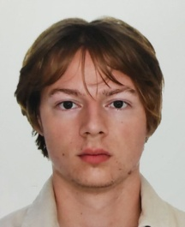  Arndt Henry Laschewski
Birthday:  Nationality: | December 2, 2002  German
Place of Birth: | Düren Birkesdorf
Address: | Voltastraße 15  50129 Bergheim  Germany
Telephone: | +49 22 71 /75 83 70
Mobile phone number: | + 49 174 165 69 25
E-Mail: | arndt.abermitdt@gmail.com
Work experience

2021 - June 2024  October 2023  November 2023  2022 – until June 2024 | Apprenticeship as a mechatronics technician for electrical and metal construction at RWE Power AG  Four-week additional qualification at the Putlitz wind farm in eastern Germany  Four-week additional qualification in 3D modelling and development in Malta  Activity as an active youth union representative
Qualification

2013 – 2021 | Attendance at the French branch of the Kreuzgasse grammar school in Cologne  Graduation: AbiBac (German-French Abitur/A-levels) in June 2021  Abitur subjects: French, German (advanced courses), history (bilingual) and biology
2009-2013  2005-2009 | Attendance at the French branch of the Geilenkircher Straße primary school in Cologne-Braunsfeld  Visit to the Franco-German kindergarten, the Ecole Maternelle Franco-Allemande in Cologne-Müngersdorf
Skills | German native  fluent in French (C2)  fluent in English (C2)  basic knowledge of Spanish (A2)  confident command of Word programmes and Simatic Step 7  Class B driving licence
Hobbies | Mountain biking, football, skiing, drawing and reading

